CHAIPEL CLASS – DID THE PUNISHMENT ALWAYS FIT THE CRIME OVER TIME?
Daily/Weekly Tasks
Reading, Reading and more Reading!
You should be aiming to read 5 times per week, but reading every day is better!


KIRFs SPRING 2:
Y5 and Y6: I CAN RECALL MY TIMES TABLE AND DIVISION FACTS UP TO 12 X 12.

CURRICULUM SPELLINGS: Keep practising these!

Enquiry Question Homework Tasks
RESEARCH  Investigate the work of the police officers in the UK.  What different types of roles are there and what do they do? | ENGLISH  Listen to the news over the week. Make notes of the crimes and their punishments. | HISTORY/MATHS  Create a timeline of crimes and their punishments since Roman Britain | ART  Design a WANTED poster for a famous real or fictional criminal.  What will their punishment be?  What reward will you give for their capture? | HISTORY  Investigate the history of Bodmin Jail.  Were there any famous punishments there?  What crimes did the inmates commit?
GET CREATIVE  Make a model of your favourite punishment!  The guillotine, rack, cucking stool, scald’s bridle etc. | ENGLISH  Imagine you rule your own country.  Write a set of laws and the punishments given for breaking them. |  | MATHS  Use a Venn diagram to sort historic (old) crimes with modern (today’s) crimes.  Which crimes appear in both?  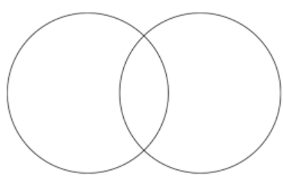 | ENGLISH  Imagine you are the famous detective, Sherlock Holmes.  Write a diary entry on a case you have just solved!

