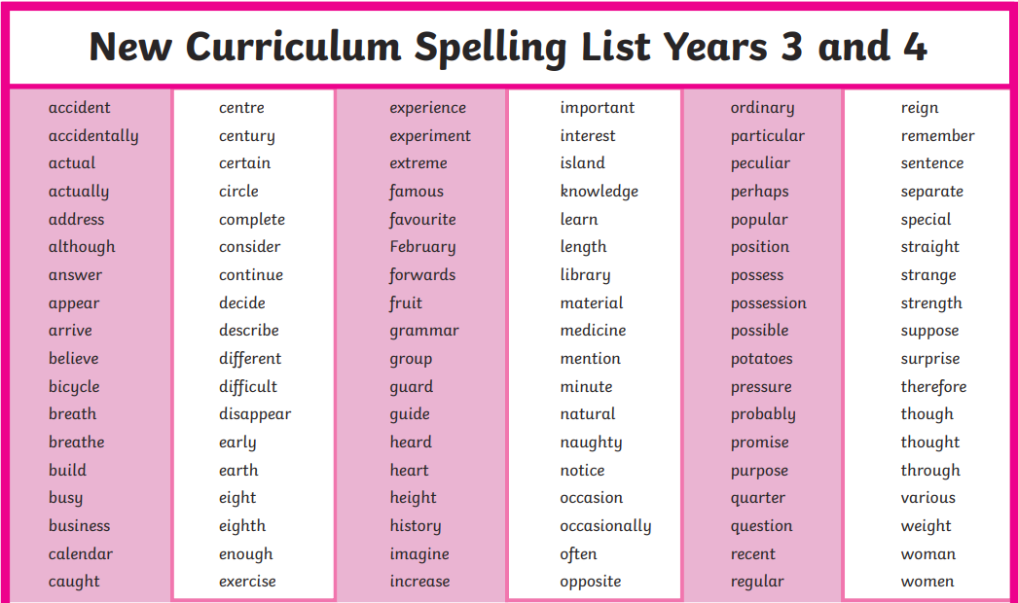
Practice any spellings that you’re still finding challenging to spell

