
Key Instant Recall Facts (KIRFs)
A guide for Parents
KIRF’s (Key Instant Recall Facts) are pieces of mathematical knowledge that we want the children to learn off-by-heart or be able to work out very quickly (rapid recall).
They are designed to support the development of the mental skills that underpin mathematics and are particularly useful when calculating, be it adding, subtracting, multiplying or dividing. KIRFs will include facts such as number bonds, counting on or back, times tables, equivalence of units of measure, factors and square/prime/cubed numbers.
Each year group as allocated key facts to focus on - a new fact per half term - in line with age related expectations that build on term after term, year after year. This will give your child a stronger foundation for which to build their mathematical understanding.
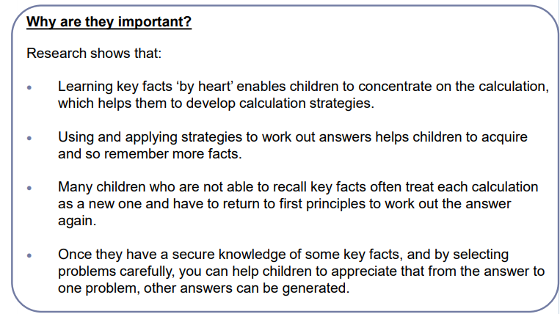
Each half term, children are given KIRFs to practice and learn at home as well as work in school. These are sent home on A4 sheets and include practical ideas for you as parents/carers to assist your child in grasping the key facts.
These KIRFs are designed for children to learn in a fun, practical way and should be taken as part of their regular homework schedule in order to gain rapid recall and fluency.
Your child is currently working on the Autumn 2 KIRF for their year group. I hope you enjoy working alongside your child. Should you have any questions regarding KIRFs then please contact me via the school.

Yours faithfully,

EMILY RANDLE Maths Subject Lead

KEY INSTANT RECALL FACTS
YEAR 6 – AUTUMN 2

I CAN IDENTIFY COMMON FACTORS OF A PAIR OF NUMBERS
By the end of this term, children should be able to list factors for a pair of numbers and identify the factors which appear in both.
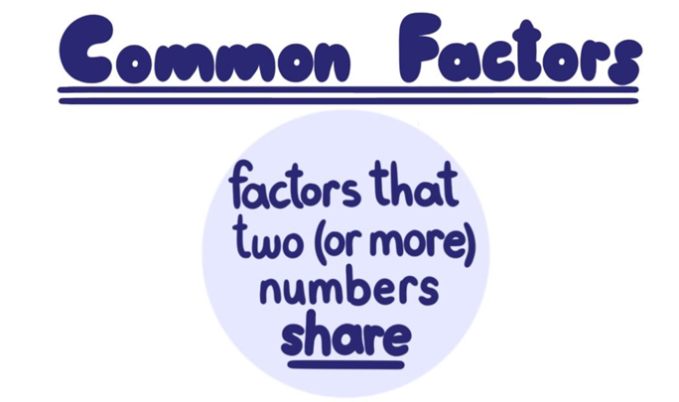
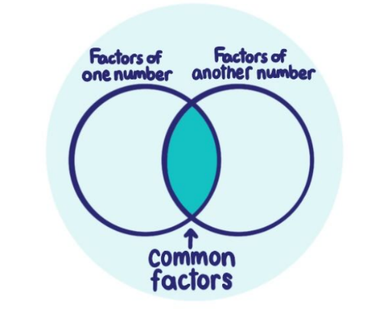

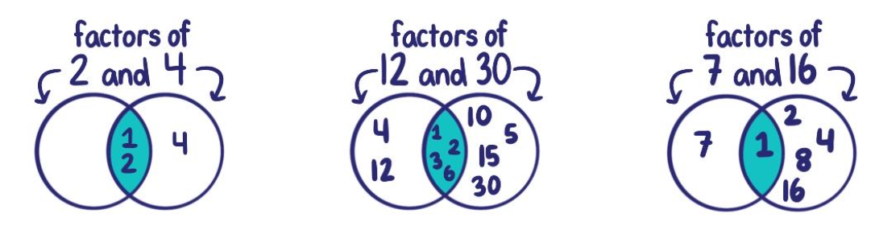
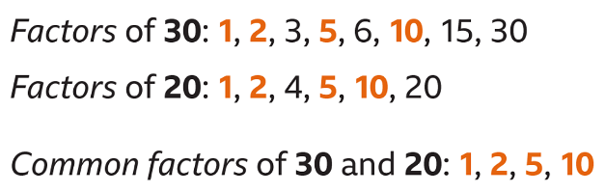

TOP TIPS
The secret to success is practising little and often. Use time wisely! Can you practise these KIRFs on the way to school either walking or by car? You don’t need to practise them all at once: you could have a fact of the day!

Try these links:

https://www.topmarks.co.uk/maths-games/multiples-and-factors



https://www.transum.org/Software/Game/Connect4/

