I can name numbers in order to 10.
I can compare 2 numbers by saying which is more or less.

By the end of this half term, children should be able to say the numbers to 10 in order and also be able to compare the size of 2 numbers within 10.

Children should say the following number names in order:  0 1 2  3 4 5  6 7 8  9 10 | They should also know which number is larger/smaller out of 2 numbers given to them:  e.g. 3 and 7 6 and 1

The aim is to be recall the numbers instantly and know which number is larger/smaller instantly.

Top Tips
The secret to success is practising little and often. Use time wisely. Can you practise these KIRFs while walking to school or during a car journey?
Perhaps you could have number cards that you can show your child and they say which number is larger or smaller.
Maybe use a number line to help compare the size of numbers

I can recognise quantities, without counting, up to 5.

By the end of this half term, children should be able to recognise a small group of objects (up to 5) without needing to count them.

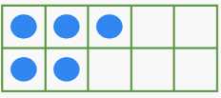  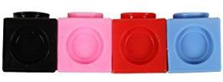 | Children should know that this tens frame shows 5 without counting.  And know this shows 4 cube without counting. |  | Children should be able to recognise this shows 3 without the need to count.

The ability to be able to recognise an amount of objects without needing to count is called subitising.
Top Tips
The secret to success is practising little and often. Use time wisely. Can you practise these KIRFs while walking to school or during a car journey?
Use practical resources – Show your child a small group of objects. Ask them how many there are without counting.

https://www.topmarks.co.uk/learning-to-count/ladybird-spots - put dots on the ladybird, how many are there?
https://www.nctm.org/Classroom-Resources/Illuminations/Interactives/Five-Frame/ - using a 5 frame

