  What is it like here? Autumn Term 2025 |  |  |  | Year 1
English  Sentence skills – Writing about the beach.  Know how to write a list.  Know the skills I need for a perfect sentence.  Narrative – Mrs. Armitage and the Big Wave  Know how to plan, rehearse and write a funny story.  Poetry – Acrostic Poems  Know the features of an acrostic poem.  Non-fiction – Biographies (famous historical figures and our own lives)  Know the features of a biography.  Narrative – The Lighthouse Keeper’s Christmas  Know how to plan, rehearse and write a narrative. | Science  Seasonal Changes  Know the 4 seasons and how they change  Know and describe weather and day length for each season  Animals including humans  Know and name animals including fish, amphibians, reptiles, birds and mammals  Know which animals are carnivores, herbivores and omnivores  Describe and compare the structure of a variety of common animals (fish, amphibians, reptiles, birds and mammals, including pets)  Know, name, draw and label the basic parts of the human body  Know which part of the body is associated with each sense | 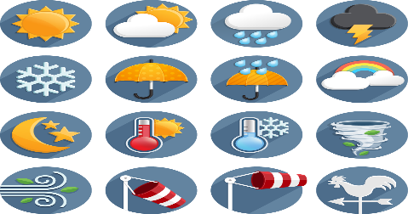  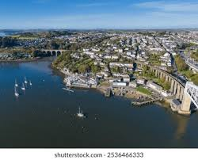 | Geography  To know that the UK is short for ‘United Kingdom’.  To know that a country is a land or nation with its own government.  To know the name of the country they live in.  To know that an aerial photograph is a photograph taken from the air above.  To know that atlases give information about the world and that a map tells us information about a place.  To know that a map is a picture of a place, usually drawn from above.  To know that symbols are often used on maps to represent features.  To know simple directional language (e.g near, far, up, down, left, right, forwards, backwards). | P.E.  Net and Wall  Know how to use the skills I have learned to play a competitive game.  Dance  Know how to practice and perform a dance based on celebrations.  Know how to work with a partner, using different levels, travel actions.  Know how to show  fluency in your dance.
Key Vocab:  sentence, capital letter, full stop, finger space, fiction, story, beginning, middle, end, poem, acrostic, adjective, onomatopoeia, non-fiction, biography, title, fact | Key Vocab:  Spring, Summer, Autumn, Winter  fish, amphibian, reptile, bird, mammal  animal, carnivore, herbivore, omnivore  head, arm, leg, foot, body, nose, hand, mouth, tongue, eye, ear, smell, touch, taste, sight, hear | 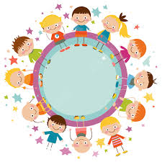 | Key Vocab:  aerial photograph, aerial view, atlas, city, country, directional language, distance, features, globe, improve, key, land, locate, location, map, north, place, questionnaire, sea, survey, symbol, village, town. | Key Vocab:  Net, wall, equipment, balls, bean bags, rackets, cones, ready, position, receive, throw, catch
D.T.  Mechanisms  Design, make and evaluate  Know that many things that move have parts inside to help them work.  Know mechanisms usually limit unwanted movement.  Know an axle allows the wheel to turn without falling off. | Computing  Technology Around Us  Know and recognise common uses of information technology beyond school. | Music  Charanga Music Units:  Hey You!  & Rhythm in the way we walk and Banana Rap  Know how to find the pulse as you are listening to music.  Know how to listen to and clap back rhythms.  Know how to sing a song and play an noted instrument. | R.E.  Know how should we care for others and for the world and know why it matters. | P.S.H.E.  Being me in my world.  Know the rights  and responsibilities as a  member of my class.  Know the rights and  responsibilities for being a  member of my class.  Know recognise  the choices I make  and understand the  consequences.
Key Vocab:  Axle, axle holder, better, careful, choose, compare, design, dislike, like, mechanism, movement,  product, straight line, tool, turn, user, wheel, worse. | Key Vocab:  software, email, internet, safety, private, personal, information, online, wifi | Key Vocab:  rhythm, pulse, rap, music, sound, pitch, low, high, listen, loud, quiet, fast, slow, steady beat, tempo | Key Vocab:  Christianity, Jesus Christ, Bible, Bethlehem, Joseph, Mary, stable, God, celebration, nativity, birthday | Key Vocab:  Responsibilities, rights, consequences, choices, others, safe, special, calm.

