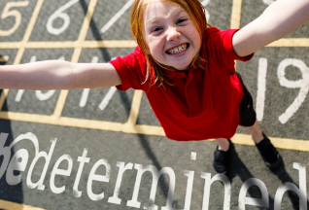
Mathematics introduces children to concepts, skills and thinking strategies that are essential in everyday life and support learning across the curriculum. It helps children make sense of the numbers, patterns and shapes they see in the world around them, offers ways of handling data in an increasingly digital world and makes a crucial contribution to their development as successful learners.
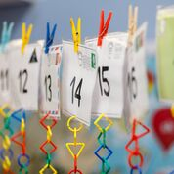
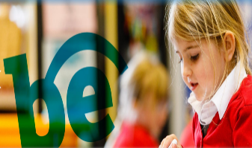
How do the children in our school learn about maths?

At our school, we believe mathematics equips pupils with a unique set of powerful tools to understand the world. These tools include logical reasoning, problem solving skills and the ability to think and work fluently.
Mathematics is important in everyday life. It is integral to so many aspects of life and with this in mind, we endeavour to ensure that children develop a healthy and enthusiastic attitude towards mathematics that will stay with them. Innumeracy is just as unacceptable as illiteracy and all children must leave our school with a secure understanding of and proficiency in maths.

Aims of Maths teaching
We follow the National Curriculum for maths. Our curriculum aims to ensure that all pupils:
- Become fluent in the fundamentals of mathematics, including through varied and frequent practice so that pupils develop conceptual understanding and the ability to recall and apply knowledge rapidly and accurately.
- Reason mathematically by following a line of enquiry, using conjecture and understanding relationships to be able to justify and use mathematical language.
- Can solve problems by applying their mathematics to a variety of routine and non-routine problems with increasing sophistication.
Principles
The following principles underpin maths teaching at our school:

Everyone is a mathematician
The idea of someone having a maths brain and others not being able to do maths is wrong. While some children may pick up concept more quickly than others everyone has the ability to learn maths and be successful.

Concrete learning precedes conceptual learning
Evidence suggests that children learn first by doing and therefore need to use concrete objects before them can understand something conceptually. It is, therefore, essential to ensure that all children have access to concrete objects in maths lessons and are able to be them for as long as is necessary for them.

Depth is preferable to breadth
When children have successfully learned a new concept, rather than moving them onto the next topic, they can be allowed to ‘go deeper’ into what they are learning, providing them with the opportunity to master concepts and apply them in different contexts.

Investigating and problem solving are essential
Mathematics isn’t simply learning a body of knowledge for children to learn; it is also a set of skills which children must be able to apply effectively. Therefore, it is essential that teaching involves a diverse range of problem solving and investigating skills as frequently as possible.

Provision
It is important that classrooms are well resourced with a variety of manipulatives to support teaching of mathematics at all stages. All children should have the chance to learn through the use of manipulatives, not just younger children or lower-ability children. Possible manipulatives could include:
- Dienes Counters
- Multilink Dice
- Place value cards Numicon
- Bead string Cuisenaire rods
Measuring equipment will also be available, which should be accessed when introducing ideas so that children can have a visual concept of what they are measuring and how big the measures are.

Planning
Planning is for the teachers who will be using it. Long term plans are available for all year groups, which are based on the National Curriculum document, to ensure that coverage is correct for each year group. Addition resources are available within each school as a resource to use when planning units of work. Planning can be organised according to the teacher’s professional judgment and the needs of the class. Learning objectives are to be taken from the long term planning and will be clear and precise and seen within children’s work alongside steps to success.

Mental fluency
Children will have opportunity to learn and practice fluency facts including number bonds and times tables. These will be monitored by class teachers and tracked termly by maths lead to ensure children making appropriate progress and if not other programmes of study are implemented to ensure they are successful.

Assessment
Teachers use formative assessment appropriately to ensure that future planning consolidates and stretches pupils appropriately. From year 2-6, summative assessments will be used at the beginning and end of the year to show progress and confirm teacher assessment at the end of the year. However, when assessing a child’s mathematical ability, our teachers understand the importance of speaking to and questioning children. While books are a useful indicator of the work a children has covered and is capable of, they are not a totally reliable way to assess a child in isolation. Books, assessment and pupil conferencing will triangulate what children do and don’t know and will be a way to assess each child.

