Arbor MIS Assessment Guide
November 2017
Prepared by Louise Gilbert and Tom Whipps

Introduction
Arbor has been introduced to all trust schools as a complete MIS. The assessment system is linked to all other aspects of Arbor, allowing quick gathering of information to allow a holistic picture to be gathered.

The use of Arbor across all schools will allow leads to analyse data centrally and provide targeted support where needed.

This guide has been put together to allow the key features of the system to be explained and as a way to quickly understand how the system can be used.

Further help and support using Arbor can be accessed through the help section of the Arbor website https://support.arbor-education.com/hc/en-us

The Basics
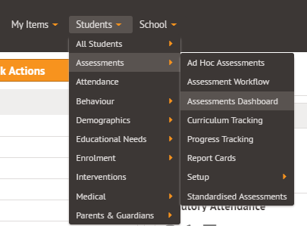
The assessment module is accessed through the Students menu.

The first screen will show the different curricula that have been added to your school. The standard assessments in all trust schools are:

Stage | Curriculum
EYFS | Development matters
KS1 | Writing and Reading (Babcock)  Maths (National Curriculum)  Yr2: End of KS SATs writing checklist.
KS2 | Writing and Reading (Babcock)  Maths (National Curriculum)  Yr6: End of KS SATs writing checklist.

Assessment in Arbor, takes place in two areas: Curriculum Tracking and Summative Tracking.

Curriculum Tracking
This is used to assess pupils on a daily basis against the curriculum statements. This gives an average mark which can then be pulled through into the summative area of the system. In this section, average scores, percentages of pupils at ARE at different times can be seen along with percentage of the curriculum that is complete. Gap analyses can also be performed here.

Summative Tracking
This segment of the system is where the data inputted into the curriculum tracking can be analysed in more detail. This area is where teachers can use the suggested grade and their professional judgement to enter formal levels using the 3 point scale. Details of this scale can be found below.

Expectations for all pupils are that they make 3 points progress from a baseline level. This progress has been entered by Arbor during the setup process.

Teacher targets can also be adapted for specific children, working outside of their year group curriculum.

Year Group | Grade Descriptor | Code to Enter | Point Value
 | 40-60 Emerging | 40-60E | 1
 | 40-60 Developing | 40-60D | 2
 | 40-60 Secure | 40-60S | 3
1 | Y1 Emerging | Y1E | 4
 | Y1 Developing | Y1D | 5
 | Y1 Secure | Y1S | 6
2 | Y2 Emerging | Y2E | 7
 | Y2 Developing | Y2D | 8
 | Y2 Secure | Y2S | 9
3 | Y3 Emerging | Y3E | 10
 | Y3 Developing | Y3D | 11
 | Y3 Secure | Y3S | 12
4 | Y4 Emerging | Y4E | 13
 | Y4 Developing | Y4D | 14
 | Y4 Secure | Y4S | 15
5 | Y5 Emerging | Y5E | 16
 | Y5 Developing | Y5D | 17
 | Y5 Secure | Y5S | 18
6 | Y6 Emerging | Y6E | 19
 | Y6 Developing | Y6D | 20
 | Y6 Secure | Y6S | 21

Trust Expectations
In line with DfE recommendations, children in the trust are expected to be assessed using the curricula for their year. Exceptions to this are SEN children, who can be enrolled in curricula below their academic year. A video showing how this can be done can be found here.

Only in very exceptional cases would children be enrolled on curricula above their year group. Higher attaining pupils will be gathered in a custom group for analysis.

Further introduction to the different sections of the Assessments Dashboard, can be found in this video guide.

Assessment Set Up Guide
NB: Following the initial setup using Excel spreadsheets, Arbor will allow teachers to input data into the curriculum tracking and summative tracking directly.

In line with DfE recommendations, all baseline data should be linked to the previous year’s grades. For example, a Year 4 child should not have a baseline of Y4E/D or S. Please ensure that baseline data is checked to ensure accuracy. This is a great opportunity to ensure that trust baseline data is correct and representative.

Arbor does not use hash tags to enable data analysis to be uniform and comparable across trust schools. Children working at greater depth within the expected standard, will be recognised by their inclusion in custom groups.

Initial data input is done in one of two ways:
- Direct inport: This can be found in the Summative Assessments section. The video on how to do this can be found here.
- Via Excel. The instructions below will show you how this can be done. Further guidance on downloading the spreadsheets and uploading completed ones can be found in these videos: Downloading and Uploading complete.

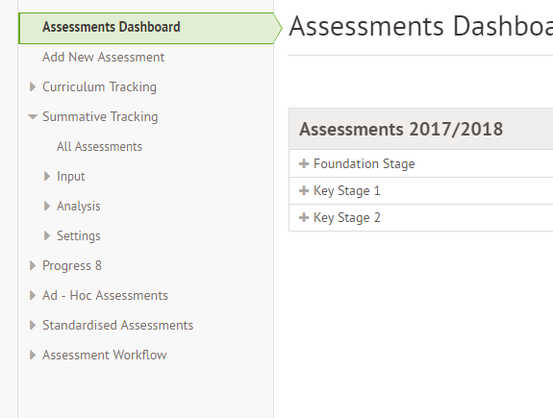
- Assessment Dashboard Summative Tracking All Assessments

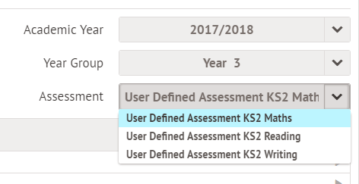

- Choose a year and then Assessment

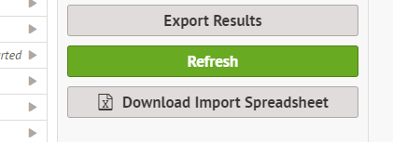
- Download the Import Spreadsheet.

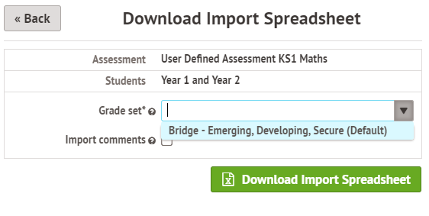

- Make sure the Grade Set is “Bridge” to ensure grade compatibility.

- Complete the columns for Baseline and Autumn 1 and save.

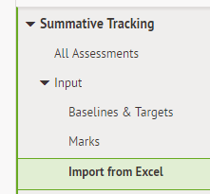

To upload completed spreadsheets:
- Summative Assessment Input Import from Excel.
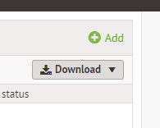

- Add (top right)

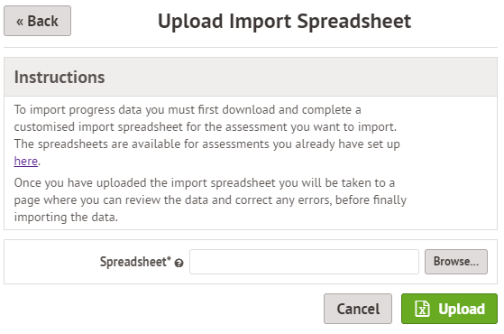
- Browse to your saved spreadsheets and upload.
- Data can be amended at this stage. Any errors in code input will be highlighted to show these need correcting.

Pupil Setup
All children in the trust are enrolled automatically into their year group and class. The assessments have been setup so they are linked to their year group.

Some SEN children will need to be enrolled in curricula outside their academic year.

To do this, there is a video guide here.

Teachers’ Guide to Curriculum Tracking

Daily use in the classroom
Curriculum Tracking is designed for teachers to give judgements against curriculum statements on a day to day basis. These judgements will, in turn, link to the summative judgements.

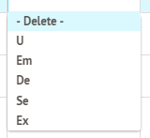
The more regularly the marks are assessed and levelled, the more accurate the summative judgements will be.

Statements can be judged Under Emerging, Emerging, Developing, Secure or Exceeding.

U can be used if the student is working on the age appropriate curriculum but has not yet met the objective.

It is important to note that pupils cannot be judged Under Emerging or Exceeding in the Summative Tracking. They will have an impact in the suggested grade but cannot be used to mark.

It is important to ensure that you are assessing the correct students against the correct statements. The guide below will help you filter the curriculum.

- Assessment Dashboard Curriculum Tracking Input Marks

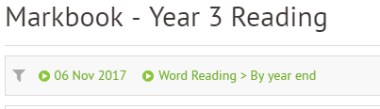
- Click on the automatically selected curriculum at the top of the screen:

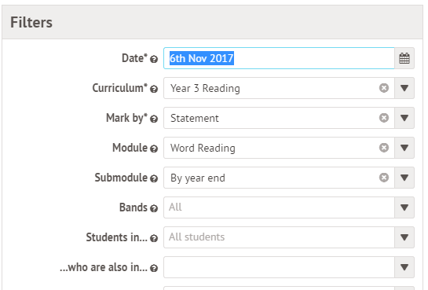
- Select the chosen filters to only choose your class and curriculum. Make sure that when inputting marks, each of the Modules and Submodules are completed to give the full suggested grade.

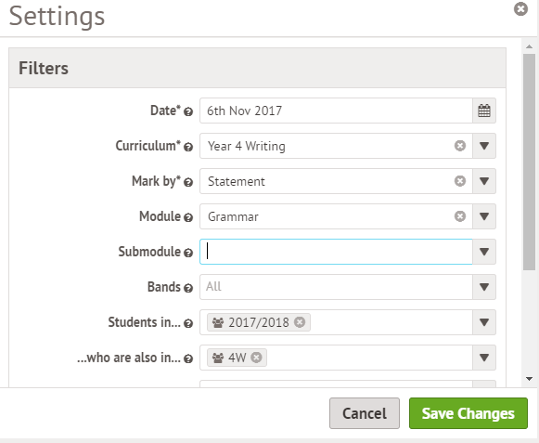

For example:

Then save data and the children will be sorted.

To input judgement, select the drop-down level against the pupil name. Bulk Mode will allow you to enter the same judgement on a selection of pupils.

The video here will show you how to enter judgements in greater detail.

Custom Groups
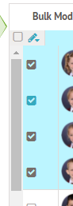
Arbor also has the capacity to create custom groups. This will allow them to be filtered for. The names of these groups can be chosen by teachers in a way that makes sense to them. The data contained in these groups will be accessible by the trust and leaders.

- To create a custom group: Select the pupils to be included using the tick box on the left of their name:

- Select the drop down pencil mark at the top to the list:

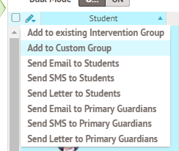
- Add to custom group:

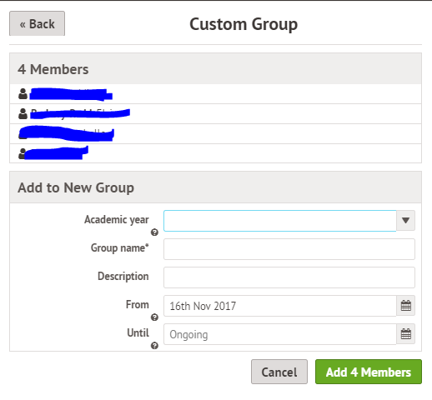

- Complete the details and add the group.

A video showing this, is available here.
The exception to this is the custom group into which teachers will place their “Most Able Pupils”. These would be identified as those children who are working at greater depth within the expected standard.

- For example, a Year 4 child who is currently working at Y4E but is able to use their learning in a wide range of activities, would be included in this group.
- Any child who was identified at the end of the previous academic year, or in a statutory data point, should also be included in this group.

To allow for comparison across the trust the naming of these groups does need to be consistent. Across the trust, the “Y ‘X’ Greater Depth Reading/ Writing/ Maths” naming convention should be followed.
- For example: “Y4 Greater Depth Reading”

Curriculum Tracking Analysis Features
There are a range of different analysis tools in the Curriculum Tracking area. All features are linked to the filter settings at the top.

Analysis areas include:

Overview:
- This will show you the percentage of children reaching “Mastery”. This is what Arbor calls ARE.
- The Average Mark is the average grade for those objectives that have been taught and marked.
- The curriculum Completion is the percentage of the curriculum that has been taught.

Progress over Time: This shows the increasing % of children achieving ARE.

Attainment by area: This shows bar models to allow gaps to be identified and targeted.

Other features are available. Once data is added at the Christmas data drop, these can be explored and explained further.

Pulling suggested grades into Summative Tracking
One of the key features of Arbor is that it lets curriculum tracking data suggest a summative level.

To ensure this is accurate, curriculum tracking should be carried out regularly as part of daily teaching and assessment.
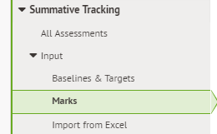
To pull through a predicted grade:

- Navigate to Summative Tracking Input Marks

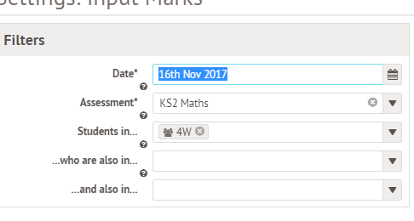
- Select the filter bar at the top and ensure the correct class, year and assessment are selected:

- Scroll down to the bottom of the filter box and select Display Suggested mark:

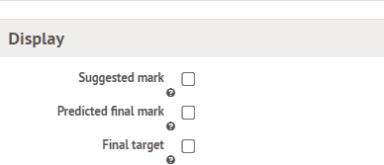

- The suggested marks, based on the Curriculum Tracking will appear in the column. These can then be combined with teacher judgement and inputted via the drop down menu into the correct assessment period.

The video showing how to do this, can be found here.

Targets are automatically set by Arbor to 3 points progress from their baseline. In Summative Input Baselines and Targets, these teacher targets can be adapted. We strongly suggest that this is done in a pupil progress meeting, alongside SLT.

Head and Assessment Lead Guide to Summative Tracking
This section on Arbor is where the data can be analysed in more detail. Reports will be automatically generated and send to stakeholders according to the trust assessment timeline.

For autumn 2, the summative data needs to have been inputted into Arbor by 15th December at the latest. Teachers should also have used the Curriculum Tracking section to allow more detailed analysis to be complete.

Arbor will generate end of term data reports on the 17th and these will be e-mailed to all relevant stakeholders by the end of the day.

Once data has been inputted, the different features of the Analysis section will become more apparent. The features include tracking groups, progress of cohorts and individuals, looking at the percentage of E, D and S pupils as well as analysing targets.

The key feature for this point is the “Statistics” section. This is effectively the “OFSTED Panic Button”. The data here can be exported in a number of different ways for analysis.
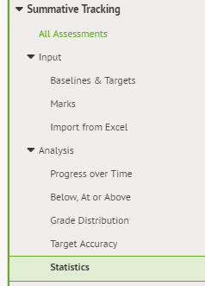
To analyse these key areas:

- Navigate to Statisitcs in Summative Tracking:

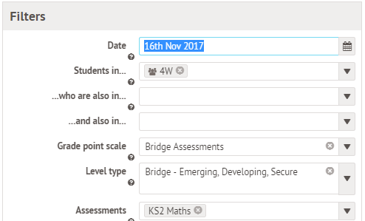
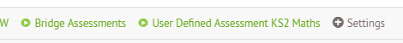
- Filter to the correct curriculum/ cohort you would like to analyse

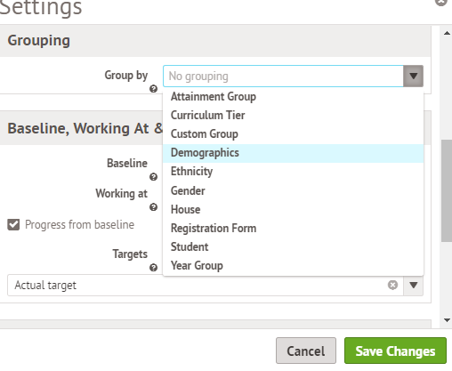

- Ensure that “Grouping by Demographics” is selected.
- Save changes and the data is presented. This can then be exported.

A video guide to this is available here.

EYFS Development Matters
Arbor has a separate EYFS curriculum uploaded. The baseline and autumn one data are uploaded in the same way as the other curricula.

Curriculum tracking is a tool that is not required to be used. If individual settings choose to use it to inform their own summative judgements, that is fine but there is no expectation from the trust to use it in the same way as KS1 or KS2. Curriculum tracking may be useful for SEN or gap analysis of small groups or cohorts.

